Name : Sakthi Manoj R Reg No : 192324236
PROGRAM 13
Combine Multiple Arrays Row-Wise
Aim:
To combine multiple numeric vectors row-wise using the rbind() function and display the resulting matrix.
Procedure:
Step 1: Open RStudio or the R console on your computer.
Step 2: Remove existing objects from the workspace using rm(list = ls()) if required.
Step 3: Create three numeric vectors containing values.
Step 4: Combine the vectors row-wise using the rbind() function to form a matrix.
Step 5: Print a message indicating that the arrays have been combined row-wise.
Step 6: Display the resulting matrix.
Output :
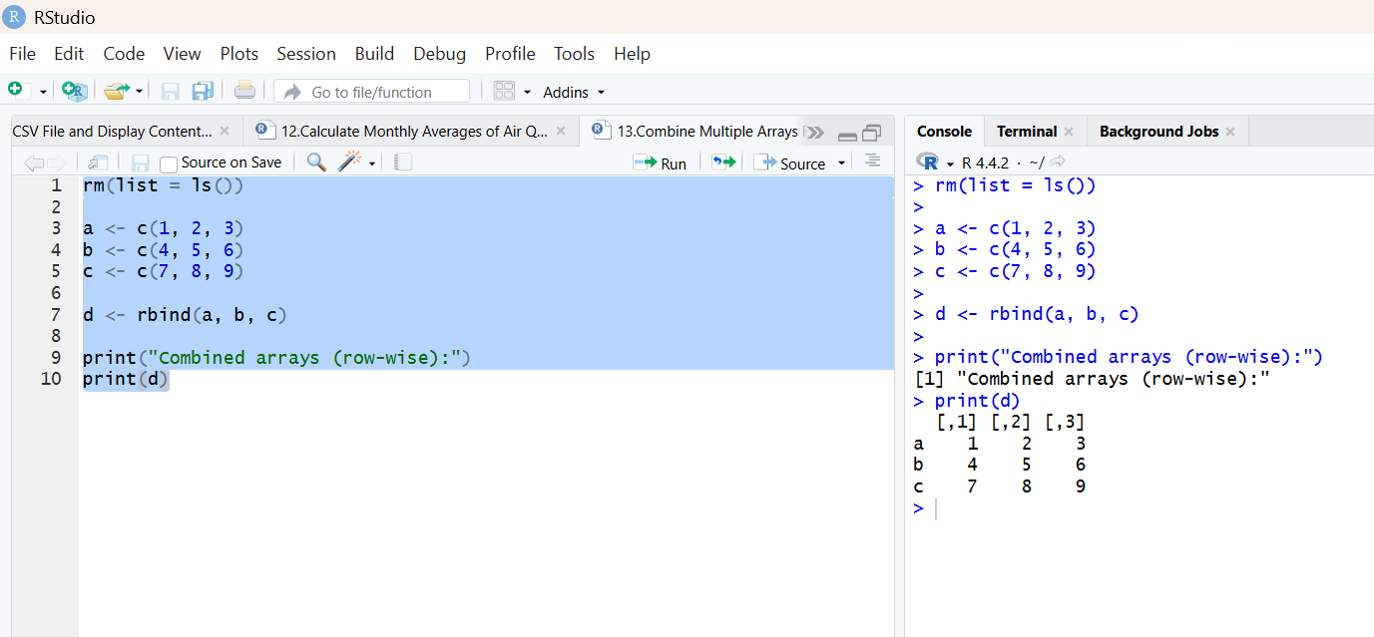
Result:
Hence the output is verified successfully.

